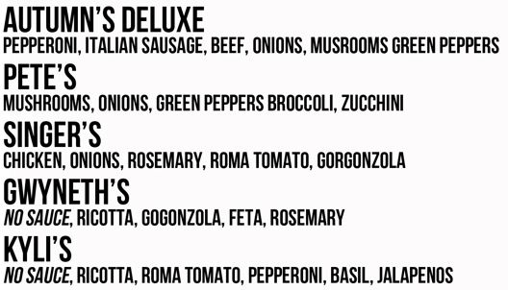

Soups

Bacon Potato

Ministrone

Pizza Soup Slop

Salads

Italian -Mushrooms , Salami, pepperoni, olives, Spinach, Lettice

House- Spinach, Carrots, Olives, tomato, feta cheese

Caesar- romaine, tomato, parmesan cheese, croutons, Caesar dressing, grilled chicken